1.Print the squares of the numbers 1 - 20. Each number should be on a separate line, next to it the number 2 superscripted, an equal sign and the result. (Example: 102 = 100)

<html lang="en">

<body>

<p>

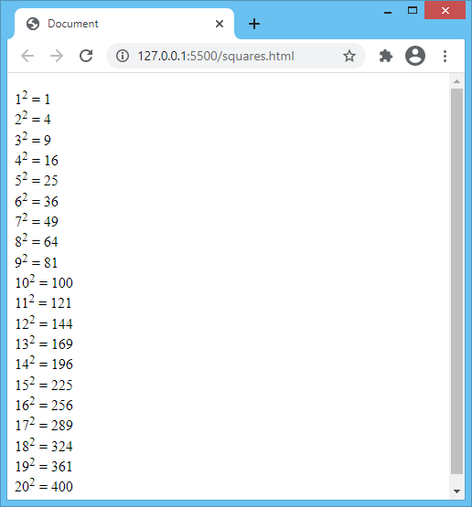 1<sup>2</sup> = 1 <br>

2<sup>2</sup> = 4 <br>

3<sup>2</sup> = 9 <br>

4<sup>2</sup> = 16 <br>

5<sup>2</sup> = 25 <br>

6<sup>2</sup> = 36 <br>

7<sup>2</sup> = 49 <br>

8<sup>2</sup> = 64 <br>

9<sup>2</sup> = 81 <br>

10<sup>2</sup> = 100 <br>

11<sup>2</sup> = 121 <br>

12<sup>2</sup> = 144 <br>

13<sup>2</sup> = 169 <br>

14<sup>2</sup> = 196 <br>

15<sup>2</sup> = 225 <br>

16<sup>2</sup> = 256 <br>

17<sup>2</sup> = 289 <br>

18<sup>2</sup> = 324 <br>

19<sup>2</sup> = 361 <br>

20<sup>2</sup> = 400 <br>

</p>

</body>

</html>

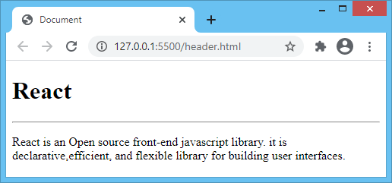2. Prints an h1 level heading followed by a horizontal line whose width is 100%. Below the horizontal line print a paragraph relating to the text in the heading.

<html lang="en">

<head>

<title>Document</title>

</head>

<body>

<h1>React</h1>

<hr />

<p>

React is an Open source front-end javascript library. it is

declarative,efficient, and flexible library for building user interfaces.

</p>

</body>

</html>

3.Print a long quote and a short quote. Cite the author of each quote. Print some deleted and inserted text of your choosing.

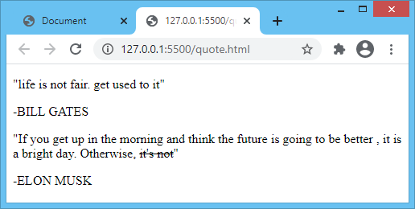<html lang="en">

<head>

<title>document</title>

</head>

<body>

<p>"life is not fair. get used to it"</p>

<p>-BILL GATES</p>

<p>

"If you get up in the morning and think

the future is going to be better , it is a bright day.

Otherwise, <del>it's not</del>"

</p>

<p>-ELON MUSK</p>

</body>

</html>

4. Print two addresses in the same format used on the front of envelopes (senders address in top left corner, receivers address in the center).

<html lang="en">

<head>

<title>document</title>

</head>

<body>

<p style="text-align: left">

Ms. Jane H. Doe <br />

Theatre Street <br />

sun City, AZ 85351

</p>

<p style="text-align: center">

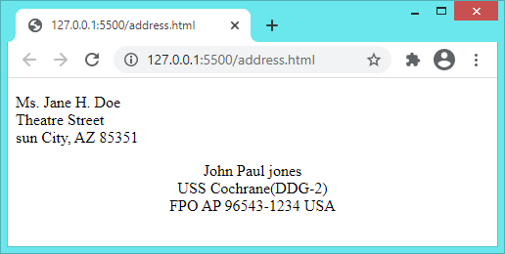 John Paul jones <br />

USS Cochrane(DDG-2) <br />

FPO AP 96543-1234 USA

</p>

</body>

</html>

5. Print ten acronyms and abbreviations of your choosing, each separated by two lines. Specify the data that the abbreviations and acronyms represent.

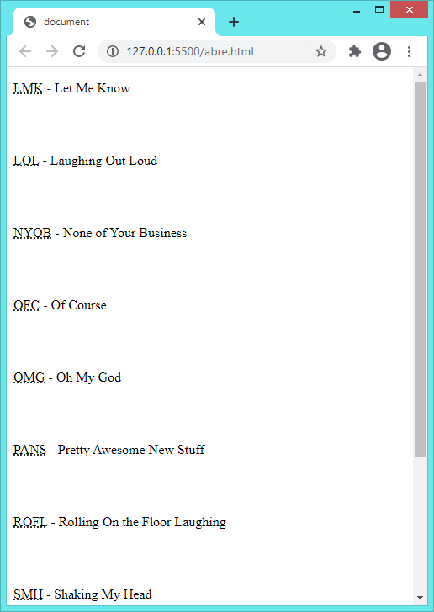

<html lang="en">

<head>

<title>document</title>

</head>

<body>

<p><abbr title="Let Me Know">LMK</abbr>

- Let Me Know</p>

<br /><br />

<p><abbr title="Laughing Out Loud">LOL</abbr>

- Laughing Out Loud</p>

<br /> <br />

<p>

<abbr title="None of Your Business">NYOB</abbr>

- None of Your Business

</p>

<br /> <br />

<p><abbr title="Of Course">OFC</abbr> - Of Course</p>

<br /><br />

<p><abbr title="Oh My God">OMG</abbr> - Oh My God</p>

<br />

<br />

<p>

<abbr title="Pretty Awesome New Stuff">PANS</abbr>

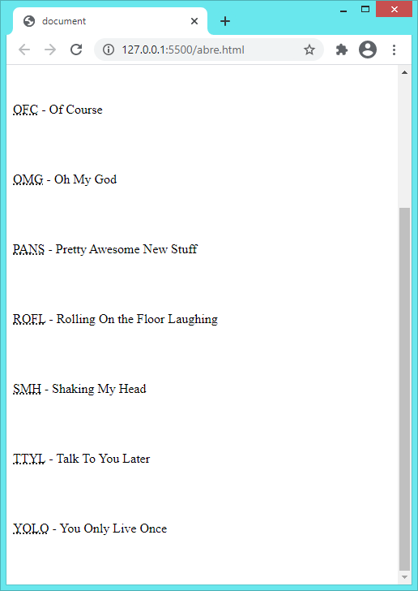 - Pretty Awesome New

Stuff

</p>

<br /><br />

<p>

<abbr title="Rolling On the Floor Laughing">ROFL</abbr>

- Rolling On the Floor Laughing

</p>

<br /><br />

<p><abbr title="Shaking My Head">SMH</abbr>

- Shaking My Head</p>

<br /><br />

<p><abbr title="Talk To You Later">TTYL</abbr>

- Talk To You Later</p>

<br /><br />

<p><abbr title="You Only Live Once">YOLO</abbr>

- You Only Live Once</p>

<br /><br />

</body>

</html>